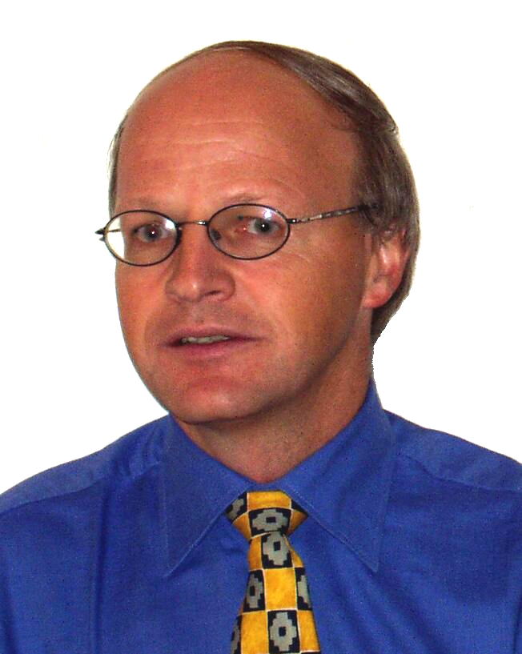
Dr. Stefan Wolfenstetter
➔ SAP Consultant since 1984 ⬅
Ausgewählte Projekte auf der Rückseite
Last Update: December 2010
Coordinates:
Address | Robinienstr. 35, D-80935 München (Germany)
Phone | +49 - 89 - 354 51 27  +49 - 172 - 962 00 72
Fax | +49 - 89 - 354 12 49
E-Mail | EDV@Wolfenstetter.de
Homepage | www.wolfenstetter.de
Degrees and Competences
Born in | 1956
Degrees | Master of Science (Tulane University, New Orleans)  Dipl. Math (TU München),  Dr. rer. nat ( Mathematics, TU München)
IT Experience | 1984 - 1985 at SAP GmbH in Walldorf  1885 - 1987 at SAP AG International in Biel (Switzerland)  1987 - 1993 at Software AG  since 1993 freelance SAP consultant
Languages | German, English and French fluently  Some knowledge in Spanish and Italian
Service Profile
Range of Services | Project planning and leading, Feasibility studies  Business modelling,  Customizing, Programming, Training
Specialities | SAP: SD, MM, some FI
Branches | Service, Trade, Production
Programming Languages | ABAP/4 and corresponding tools
Recent references | ADAC, Tech Data IT  More on request or at www.wolfenstetter.de

Selected Projects:
Year | Project | Branch | Activities
2009 to 2010 | Ship & Debit Rollout + Reconciliation | Trade | Adaption and Rollout of the “Ship & Debit Solution” to the Headquarter in US  Development of a Reconciliation Module for Finance
2006 to 2008 | Invoicing | Service | Invoicing in about 50 independent departments via SAP SD  - Coaching for a feasibility study  - Programming of the core functions
03/2005 to 2008 | Ship & Debit Longterm Solution  (supplement to standard SAP SP) | Trade | Project “Ship & Debit Longterm Solution”  - Coaching for the requirement planning  - Establishing of the technical concept  - Programming of the core functions  - Assistance for implementation  - Programming of Add-Ons  - Performance Optimization
2005 to 2006 | SAP Implementation Introduction of SAP R/3 ( FI, CO, AA, MM, SD) | Service  (School) | Introduction of SAP R/3 ( FI, CO, AA, MM, SD)  - Project Manager  - Customizing of MM and SD  - Programming of Add-Ons (2007-2008)
2004 |  | Service  (School) | Project Manager,  Customizing of MM and SD
2004 | Modifications in SD | Trade | Modifications  for passing requirements and for pricing
2004 | Invoicing for video toll | Service | Conception und realization of an invoicing system for video toll (Brenner Pass)
2003 | Car battery service | Trade | Handling of decentralised sale of car batteries with belated input in SAP SD
2002 to 2003 | Conversion  R/2 => R/3 | Service | - Conception for R/3 mapping  - Estimation of costs and time  - Customizing + programming  - Training  - End user support
2001 to 2002 | Ship & Debit | Trade | Conception und realization  of a system for handling “Ship & Debit” including interfaces to a subsystem
1999 | Invoicing for helicopter rescue | Service | Conception, realisation and introduction of an invoicing system for a helicopter rescue service
1998 | „Alles über RM“  (“All by RM”) | Service | Project to use the SAP purchasing system RM for all departments with very different requirements
1997 | Invoicing of touristy Services | Service | Conception, realisation and introduction of an invoicing system for toll cards, vignettes and similar things for about 500 sales stations (some of them abroad) and 10 suppliers
1995 to 1996 | SAP R/3 introduction | Production | Study for feasibility and scale to introduce SAP-SD for a company establishing phone networks
Further projects on request or at www.wolfenstetter.de .

